
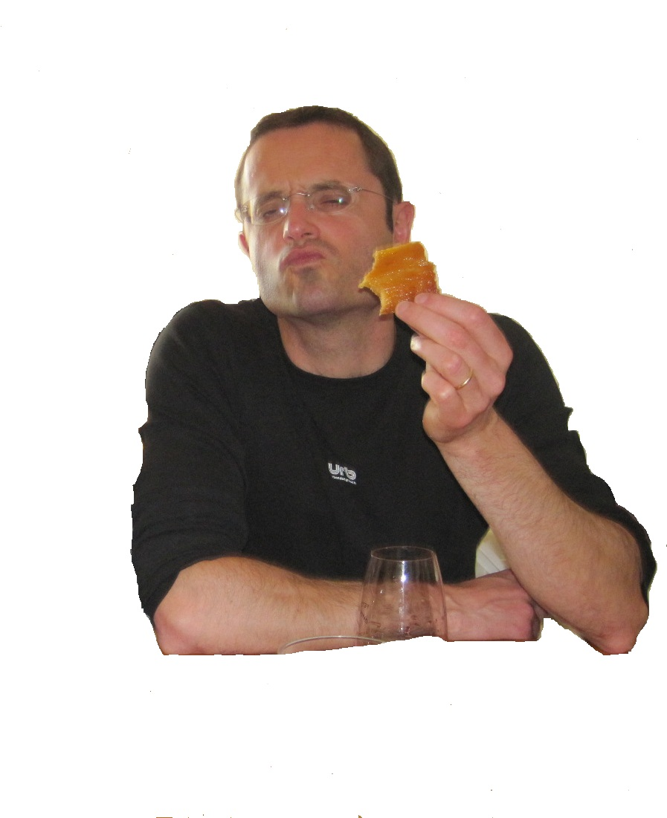
PRESIDENT
OLIVIER
Toi aussi, change l’histoire
OLIVIER
PRESIDENT

